 --> 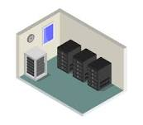 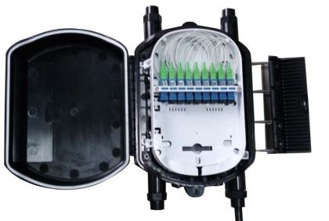 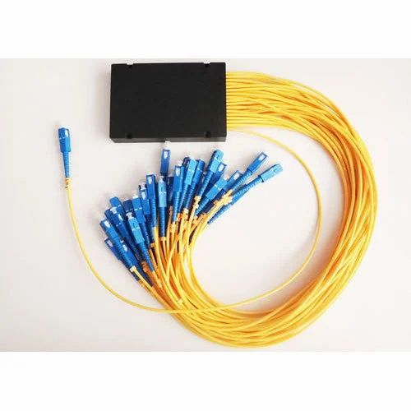

Fiber splitter/filter

Fiber splice enclosure

Room

Building

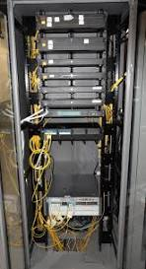 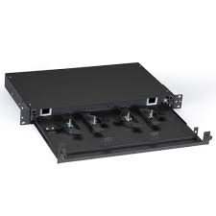 

Fiber splitter/filter

Fiber shelf

Fiber rack

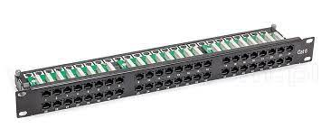 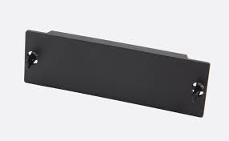

Fiber blanking plate

Fiber patch panel

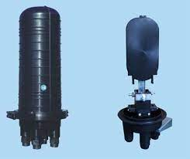  

Fiber splitter/filter

Fiber splice enclosure

Closure

  

Fiber splitter/filter

Fiber shelf

Fiber rack

 

Fiber blanking plate

Fiber patch panel

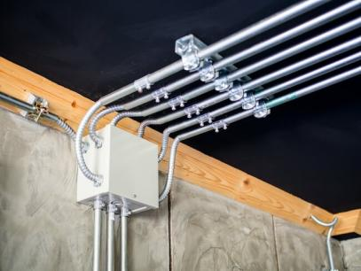

Conduit

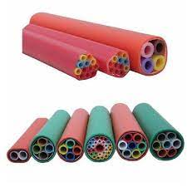

Fiber Duct

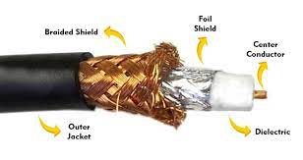

Cable -> Coax cble

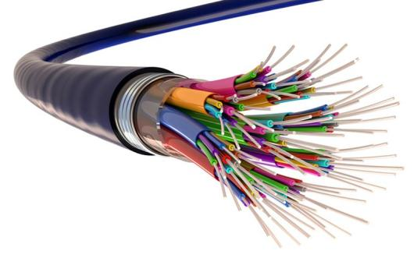

Fiber cable

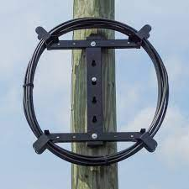 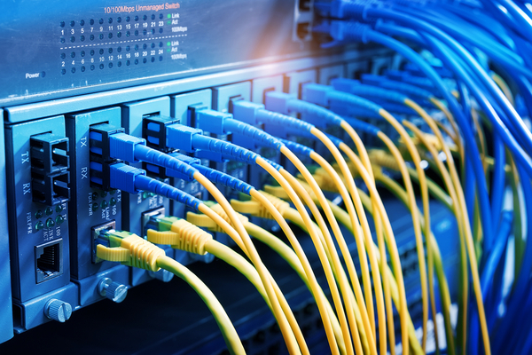

Fiber

Fiber slack

|  |  |  |  |  |  |  |
| --- | --- | --- | --- | --- | --- | --- |
| **SL.No** | **Object** | **Field** | **Problem** | **%** | **Probable Cause** | Prodapt comments |
| 1 | fiber\_cable | vmx\_conduits | Bad reference 'conduits/0' | 100% | Code | IMG_256  for many records the data from B$gc\_contain table value we have '0',hence we are returning 'conduits/0',  does IQGEO wants 'Null' instead of 'conduits/0'? |
| 2 | fiber\_cable | vmx\_conduits | Referenced object not in sample data | Many | Data? (to be confirmed in GCOMMS) | as discussed, this will be data issue |
| 3 | fiber\_cable | in\_equipment | Referenced object not in sample data | Many | Data? (to be confirmed in GCOMMS) | as discussed, this will be data issue |
| 4 | fiber\_cable | out\_equipment | Referenced object not in sample data | Many | Data? (to be confirmed in GCOMMS) | as discussed, this will be data issue |
| 5 | fiber\_cable\_label | vmx\_id | Values are wrong (contain FID of cable, not label) | 100% | Code | fiber cable label  IMG_257  fiber cable table  IMG_258  in gcoms does maintain any sperate FIDs for fiber cable label, fiber slack, fiber features due to logic implementation in application |
| 6 | fibre\_splice\_enclosure | vmx\_housing | Referenced object not in sample data | 21% |  | IMG_259  for few records under fiber splice enclosure the owner1\_id value is null, hence retuning the null values, this is also data issue |
| 7 | fiber\_splitter | n\_fiber\_out\_ports | Value wrong (is total ports, not TX port count) | 100% | Code | need to more clarity on this |
| 8 | fiber\_duct | vmx\_housings | Includes invalid IDs 'conduit/' | Many | Code | in shared file we not able to see 'conduit/' value |
| 9 | fiber\_inner\_duct | vmx\_housings | Values do not make sense (all reference another fiber\_inner\_duct) | 100% | Code | the issue is fixed in our package |
| 10 | area\_boundary | boundary | Not a valid polygon | 100%? | Code | Please refer the latest file shared on 24th Jan - IQGeo Folder Name - vmx\_polygon\_fix  IMG_260  IMG_261 |
| 11 | port\_range\_connection | cable | Contains references to equipment, not cable | Many | Code |  |